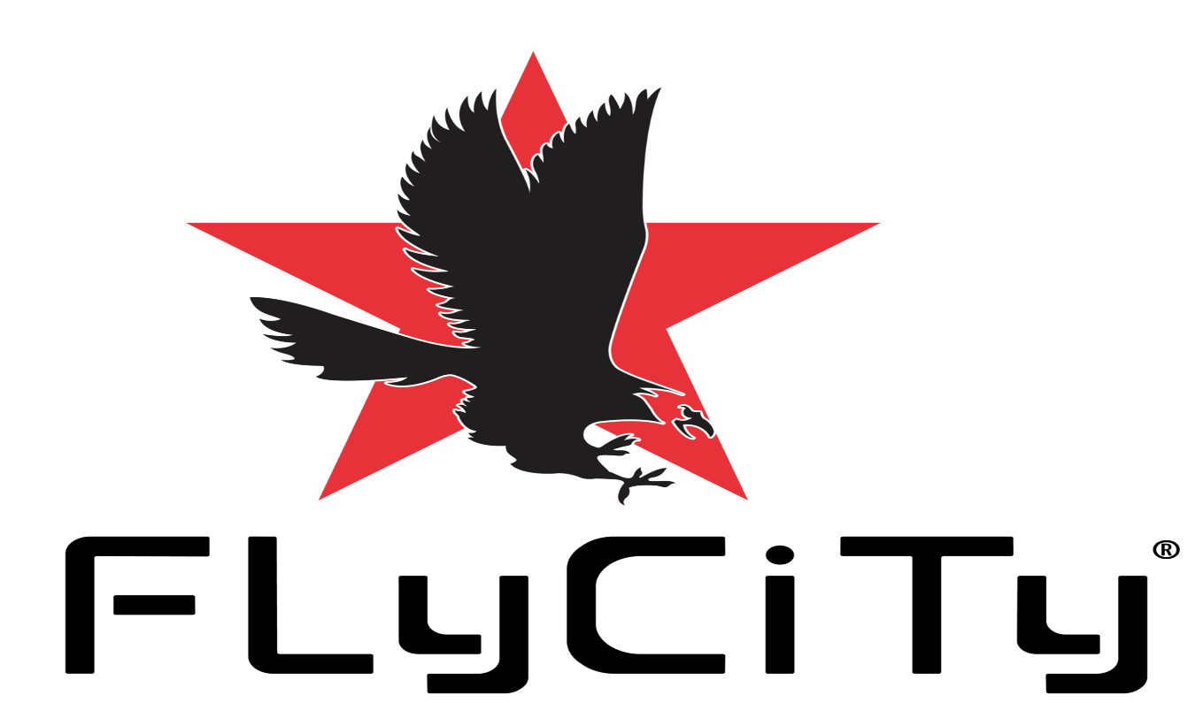Ray’s Workout Schedule For The Fitness Enthusiasts!
(Weight Loss & Muscle Gain)
Shop Fitness Products At Exclusive Discounts 15% Off Your First Order!
Claim Your Discount Code Today At https://shopflycityfitness.com/
https://www.flycityfitness.com/fitness-wellness
Mon- Chest and Triceps
- Chest: Bench Press: 3 sets, 10-12 reps
- Chest: Incline Press: 3 sets, 10-12 reps
- Chest: Push-ups: 3 sets, (failure)
- Chest: Decline Press: 3 sets, 10-12 reps
- Triceps: Tricep Pushdown 3 sets, 10-12 reps
- Triceps: Standing Dumbbell Extension 3 sets, 10-12 reps
- Triceps: Dumbbell Kickbacks 3 sets, 10-12 reps
- Triceps: Overhead Barbell Extension 3 sets, 10-12 reps
Tues- Legs
- Squats 3 sets, 10-12 reps
- Walking Lunges 3 sets, 10-12 reps
- Leg Extension 3 sets, 10-12 reps
- Leg Press 3 sets, 10-12 reps
- Cardio Session: Run 1 mile (Moderate pace).
Weds- Back and Biceps
- Back: Lat Pulldowns 3 sets, 10-12 reps
- Back: One Arm Dumbbell Row 3 sets, 10-12 reps
- Back: Seated Row 3 sets, 10-12 reps
- Back: Dead lift 3 sets, 10-12 reps
- Bicep: Concentration Curls 3 sets, 10-12 reps
- Bicep: Barbell Curls 3 sets, 10-12 reps
- Bicep: Spider Curls 3 sets, 10-12 reps
- Bicep: Hammer Curls 3 sets, 10-12 reps
Thurs- *Abs Hiit Cardio (Core) Workout Session* Continuous (3 Sets) 20 second Rest Between Each Set. *Repeat All 6 Exercises 3 Times*
- Plank: 30 seconds
- Abdominal Crunch 30 reps
- Bicycle Crunch 10-12 reps each side
- Flutter Kicks 10-12 reps each side
- Russian Twist 10-12 reps each side
- Leg Raises 10-12 reps each side
- Cardio Session Run 1 Mile. (Moderate pace)
You don’t need a gym on Thursdays. This can be done at home or outside.
Fri- Forearms and Shoulder
- Forearm: Seated Dumbbell Wrist Curls 3 sets, 20-25 reps
- Forearm: Farmers Carry, Walk 20 yards w/ a pair of Kettle or Dumbbells that equal half your body weight, 3 sets. (Intermediate/Advanced use your full body weight).
- Forearm: Seated Dumbbell Reverse Wrist Curls 3 sets, 20-25 reps
- Forearm: BAR HANG! (Failure)
- Shoulders: Alternate Front Raise 3 sets, 10-12 reps
- Shoulders: Standing Military Press 3 sets, 10-12 reps
- Shoulders: Face Pulls 3 sets, 10-12 reps
- Shoulders: Side Lateral Raise 3 sets, 10-12 reps
Sat- Cardio: 2-3 Miles. (Moderate Pace)
Sun- REST. Have a cheat meal, you earned it.

SUPPLEMENTS:

Now, if you are just starting don’t get overwhelmed by all the products they have out there. Keep it simple. Also keep in mind you can get all the vitamins and protein you need from food. Only problem is not everyone has time to cook several meals a day in order to fulfill the proper vitamin and protein intake your body needs daily. This is what works for me.

WHEY - 4 scoops of protein throughout the day which equals about 96 grams, the rest you can get from food. You want your protein intake to match your body weight. Protein repairs the damaged muscle which occur after each workout and makes your muscles bigger and stronger. Amino acids repair the micro-tears.

https://amzn.to/3jNpLSC

COCONUT OIL - Good for fat loss, heart health and brain function. Coconut oil is also considered a superfood. Great source of medium chain triglycerides. Contains a unique composition of fatty acids.

https://amzn.to/3jNdP3k

DAILY MULTIVITAMIN - Good for your overall health. Whether you work out or not you should be taking your multivitamins daily. The mega men "Sport" vitamins I take improves performance which helps use fatty acids as energy, muscle function which features branched chain amino acids to fuel muscles and contains a good source of antioxidants. For women, the “Opti-Women Multivitamin” by Optimum Nutrition will work just fine. 100% DV for iron, zinc & other minerals to help support immune and overall health.

https://amzn.to/3qhKS1U

VITAMIN D3 - D3 comes from sunlight and most people do not get enough of it. If you work inside of an office building 8 hours a day, you may want to consider taking this vitamin. D3 supports strong bones and immune health. I personally take 125 MCG (5000iu).

https://amzn.to/3pn0qjw

FISH OIL OMEGA 3'S - Another fatty acid... also supports heart, brain, skin, eye and joint health. Fish oil is great for weight loss and good for your overall health.

https://amzn.to/2Ze6SyW

CREATINE - Enhances the size and fullness of your muscles. Creatine is NOT some synthetic compound made in a lab. It is already produced in your body by your kidneys, pancreas and liver. Various scientific studies prove it is safe to use as a supplement. I personally take 5 grams of creatine POST workout with a protein shake. Creatine is great for muscle growth but only take if you feel it is right for you.

https://amzn.to/2ZH87qq

​
***FOOD FOR THOUGHT***

Consume 1800-2000 Calories a day to lose weight. The easiest way to keep track is to eat 500 calories for breakfast, 600 calories for lunch, and 700 calories for dinner. I like to leave the remaining 200 calories as wiggle room just in case I unintentionally go over. Do not eat past 8 P.M or 2 hours before bed. If hungry, you can snack on peanuts, almonds, grapes, an energy bar, Greek yogurt, apple slices with peanut butter, mix berries, or have a protein shake. (VERY IMPORTANT) You must drink up to 8 cups to a gallon of water a day. Also, make sure you are getting up to 8 hours of sleep every night.

​

FOODS (Pre-Workout): Eggs, Greek yogurt, Salmon, Oatmeal (OLD FASHION) Quaker Oats, MAPLE syrup with whole-grain waffles, black coffee… absolutely NO creamer or sugar. Broccoli, spinach, Lemon, Almonds* Peanut butter, lean meats, salad, skim milk, grapes, tuna, bananas, GREEN TEA*, COCONUT WATER. Breakfast and lunch should contain little CARBS!

FOODS (Post Workout): NOW YOU CAN LOAD UP ON CARBS! Brown rice, grilled chicken, tuna, cottage cheese, fruits, sweet potatoes, whole wheat bread, beans, peas, quinoa, walnuts, fresh vegetables, sunflower seeds (Low Sodium), whole wheat pasta, whole grain cereal, orange juice (Low Sugar), apple juice (Low Sugar), cranberry juice (Low Sugar), WATER!

Foods to AVOID: Soda, Candy, sugar, white flour, cake, candy, potato chips, mayo, pies, alcohol, cookies, sugary cereals, refined grains, processed syrup, pancakes, fast food, Pizza. Leave all of this for your Sunday cheat meal… or even better… don’t have it at all, lol.

I’m realistic here and I made this workout plan in order for you to follow it to the best of your ability. Cheat meals are fine AS LONG AS YOU FOLLOW THIS COMPLETE WORKOUT SCHEDULE. IF you skip a workout, you DO NOT deserve a cheat meal. IF you are not drinking up to 8 cups of water a day, you DO NOT deserve a cheat meal. IF you are barely sleeping 8 hours a night, you DO NOT deserve a cheat meal. IF YOU ATE ANY COOKIES, ICE CREAM OR FAST FOOD IN THE MIDDLE OF YOUR WORKOUT WEEK! THEN YOU DON’T DESERVE A CHEAT MEAL!!!! I think you see where I am going with all of this. Follow this workout schedule and make sure to always remain CONSISTENT AND STAY MOTIVATED.

​

NOTE: IN ORDER TO SEE THE BEST RESULTS POSSIBLE, YOU MUST MAINTAIN A CLEAN DIET. MAKE SURE TO DRINK LOTS OF WATER AND MOST IMPORTANTLY, STAY CONSISTENT. NOW, LET'S GET THIS WORK!!

The KETO Diet!

P.S. If you’re interested in trying the KETO Diet, check out the KETO recipes e-Book I sent you. The e-Book goes into great detail on how to get started.

Disclaimer: This page contains affiliate links. Any product that is purchased through this page will give me a small commission at no additional cost to you. This helps support the website and allows me to continue to make content like this. All the products I endorse on this page are products I have used or benefitted from. I would never recommend a product I have never used myself. Thank you for your support!
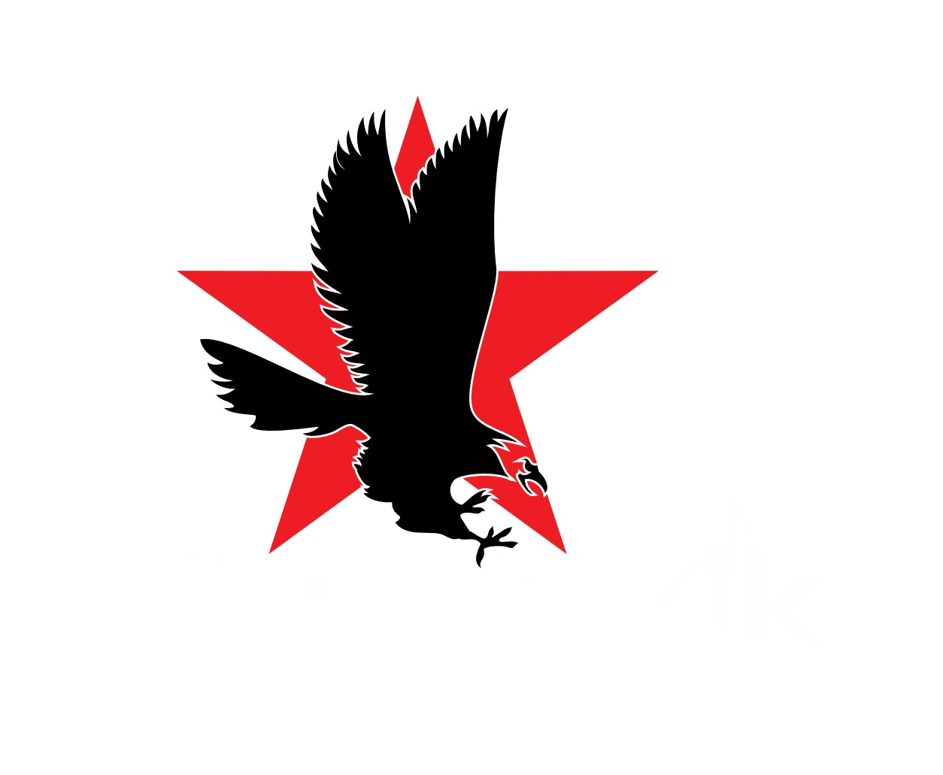
© 2023 - Raymond Peña, FLyCiTy Recordings, LLC | New York, NY | All Rights Reserved.

